Day 7

Cw:

import React, { useState, useEffect } from 'react';

import axios from 'axios';

const BookList = () => {

  const [books, setBooks] = useState([

    { id: 1, title: 'Irrfan Khan: A Life in Movies', author: 'Shubhra Gupta' },

    { id: 2, title: 'The World: A Family History', author: 'Simon Sebag Montefiore' },

    { id: 3, title: 'Breaking Barriers: the Story of a Dalit Chief Secretary', author: 'Kaki Madhava Rao' },

    { id: 4, title: 'Ambedkar: A Life', author: 'Shashi Tharoor' }

  ]);

  const [newBook, setNewBook] = useState({

    id: '',

    title: '',

    author: ''

  });

  useEffect(() => {

    fetchData();

  }, []);

  const fetchData = async () => {

    try {

      const response = await axios.get('https://example.com/books');

      const data = response.data;

      const transformedData = data.data.map(book => ({

        id: book.id,

        title: book.title,

        author: book.author

      }));

      setBooks([...books, ...transformedData]);

    } catch (error) {

      console.error('Error fetching data:', error);

    }

  };

  const handleInputChange = event => {

    const { name, value } = event.target;

    setNewBook({

      ...newBook,

      [name]: value

    });

  };

  const handleAddBook = () => {

    const updatedBooks = [...books, newBook];

    setBooks(updatedBooks);

    setNewBook({ id: '', title: '', author: '' });

  };

  return (

    <div>

      <h1>Book List</h1>

      <ul>

        {books.map(book => (

          <li key={book.id}>

            <strong>{book.title}</strong> by {book.author}

          </li>

        ))}

      </ul>

      <div>

        <h2>Add a New Book</h2>

        <form>

          <label>

            ID:

            <input

              type="text"

              name="id"

              value={newBook.id}

              onChange={handleInputChange}

            />

          </label>

          <br />

          <label>

            Title:

            <input

              type="text"

              name="title"

              value={newBook.title}

              onChange={handleInputChange}

            />

          </label>

          <br />

          <label>

            Author:

            <input

              type="text"

              name="author"

              value={newBook.author}

              onChange={handleInputChange}

            />

          </label>

          <br />

          <button type="button" onClick={handleAddBook}>

            Add Book

          </button>

        </form>

      </div>

    </div>

  );

};

export default BookList;

output :

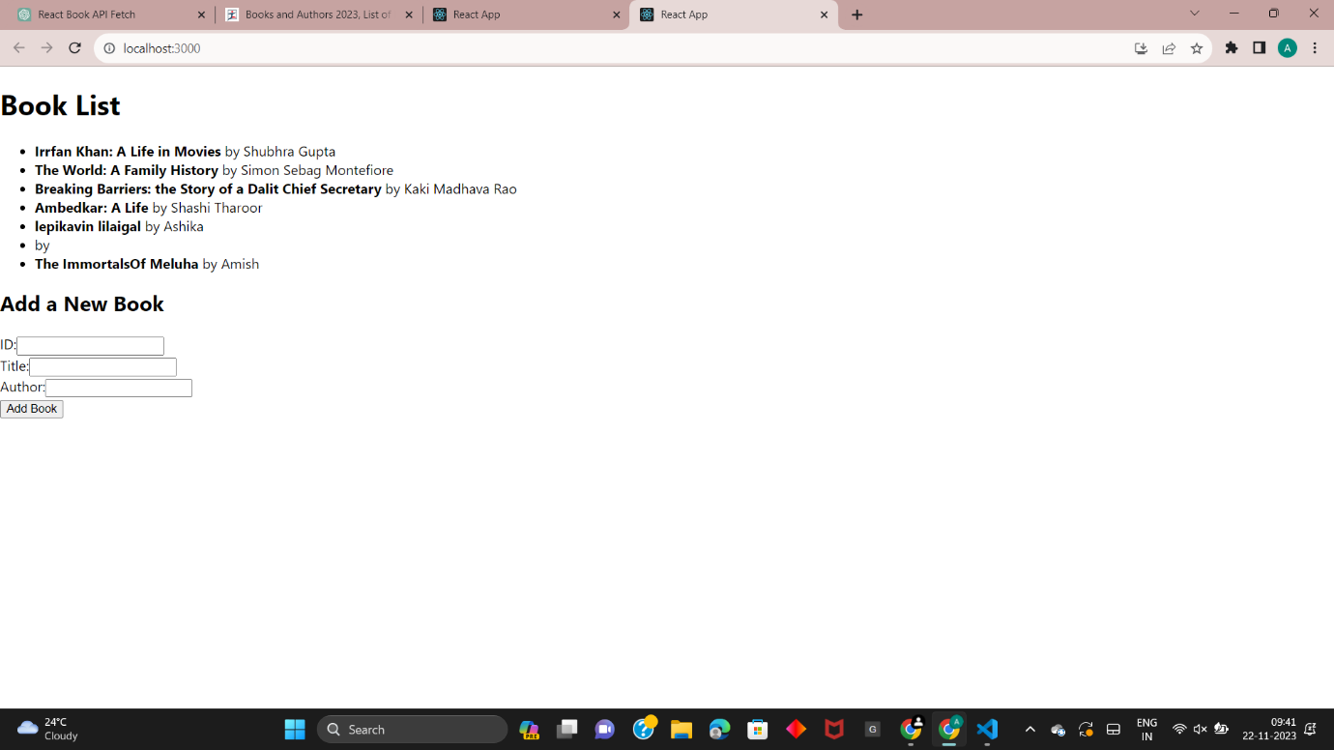

import React from 'react';

const withProductList = (products) => (WrappedComponent) => {

  return class extends React.Component {

    render() {

      return <WrappedComponent products={products} />;

    }

  };

};

const ProductList = ({ products }) => (

  <div>

    <h2>Product List</h2>

    <ul>

      {products.map((product, index) => (

        <li key={index}>

          <img

            src={product.imageUrl}

            alt={product.name}

            style={{ maxWidth: '150px', maxHeight: '150px' }} // Adjust the size as needed

          />

          <p>{product.name}</p>

          <p>Price: ${product.price}</p>

        </li>

      ))}

    </ul>

  </div>

);

const sampleProducts = [

  {

    name: 'Apple',

    price: 19.99,

    imageUrl: 'https://nurserynisarga.in/wp-content/uploads/2021/08/Hot-climate-Apple.jpg',

  },

  {

    name: 'Mango',

    price: 29.99,

    imageUrl: 'https://m.media-amazon.com/images/I/61m0sXqceLL._AC_UF1000,1000_QL80_.jpg',

  },

];

const EnhancedProductList = withProductList(sampleProducts)(ProductList);

const App = () => (

  <div>

    <EnhancedProductList />

  </div>

);

export default App;

output:

